MAIN ORTHOGRAPHIES
- Akkadian – cuneiform (pictographic) system
- Arabic – primarily a tri-consonantal system based on the root (ktb 'book, write, read, has read, is reading, library, etc.)
- Cherokee– each symbol represents a consonant plus vowel (syllabic writing system)
- Chinese – each symbol represents a word (logographic) or an idea (ideographic).
- Cyrillic – phonemic alphabet representing consonants and vowels.
- Devanagari – each symbol represents a consonant plus vowel (syllabic writing system)
- Egyptian, Ancient – over 2000 hieroglyphic symbols, either representing an idea associated with that object (ideographic) or a sound contained in the object's name (phonological) < http://www.greatscott.com/hiero/hiero_over.html> The modern rebus gives an idea how to interpret hieroglyphs:
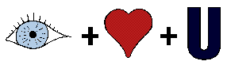
- Greek – phonemic alphabet representing consonants and vowels.
- Phoenician – 22 signs adopted from Egyptian hieroglyphs = the earliest symbol-for-sound writing system, but vowels were usually omitted.
- Roman – phonemic alphabet representing 21 consonants and 5 vowels.

SOME LANGUAGES & THEIR WRITING SYSTEMS
Albanian uses the Roman alphabet with 2 diacritic characters; digraphs are sorted separately.
Armenian has a unique alphabet of thirty-nine letters with its own sort order.
Baluchi is written in an extended Arabic script with both nastaÕliq and nasx forms; letters sort on similarity of shape.
Bhutanese (Dzongkha) uses its version of Devanagari script with a unique sort order.
Bulgarian uses the Cyrillic system.
Cebuano – accent is ignored in the orthography; otherwise see Philippine Languages.
Chinese – each symbol represents a word (logographic) or an idea (ideographic). All symbols are fixed in value, so readers of each Chinese dialect pronounce them their own way.
Dari – uses a modified version of the Arabic script.
English – 26 letters of the Roman alphabet represent 25 consonants and 21 vowels. The modern writing system is a combination of historical (knight), phonetic (pet), phonemic (part), and morphophonemic (walked, houses) principles.
Haitian Creole uses the Roman alphabet; standard sort order.
Hausa uses a highly modified Roman alphabet with hooked (IPA) symbols for glottalized consonants, macrons and tone marks for vowels; modified characters sort after their plain counterparts.
Hiligaynon – accent is ignored in the orthography; otherwise see Philippine Languages.
Hindi uses the Devanagari alphabet with its own sort order.
Ilokano (Ilocano) – accent is ignored in the orthography; otherwise see Philippine Languages.
Philippine languages (the majority) use 20 letters of the Roman alphabet; k sorts as the third letter, the letter e more often represents schwa [ə] or barred i, and the digraph ng [ŋ] is sorted after n: «a, b, k, d, e, g, h, i, l, m, n, ng, o, p, r, s, t, u, w, y»
Papiamentu uses a modified Roman alphabet with 2 diacritics on 4 vowels and the Spanish – uses a modified Roman alphabet (ch, ll, ñ, rr); these sort after their plain counterparts.
Pashto uses an extended Arabic script; letters sort on similarity of shape.
Romanian uses a modified Roman alphabet with diacritics on 3 vowels and 2 consonants; these sort after their plain counterparts.
Russian uses the Cyrillic system.
Serbian – uses the Cyrillic system.
Shan uses a rounded version of Devanagari script (somewhat similar to Burmese) with a unique sort order.
Slovenian – uses the Roman system with some diacritics and digraphs.
Somali and Oromo (Cushitic family) use the Roman alphabet; consonant digraphs «dh, sh» are sorted as separate letters.
Sotho, Xhosa, and Zulu use the Roman alphabet; consonant digraphs are sorted as separate letters.
Swahili uses the Roman alphabet.
Tagalog – accent and glottal stop are ignored in the orthography; otherwise see Philippine Languages.
Tamil uses a South-Indian syllabary with its own sort order.
Tausug – long vowels are ignored in most orthographic renditions, some use a macron; otherwise see Philippine Languages.
Yoruba uses a modified Roman orthography with diacritics on both vowels and consonants; these sort after their plain counterparts.
Cyrillic Alphabet (Programmed Guide Related by SHAPE or to English graphemes), rdz

PHONETICS (+ SHAPE or SIMILARITY TO ENGLISH ) | GRAPHEME
[a] A a {=} | А а
[g] (GREEK) | Г г
[--] (hard sign) {!!} (SMALL b WITH LEFTWARD HOOK) | Ъ ъ
['] (soft sign) {!!} (SMALL b) | Ь ь
[y] {!!} (SMALL bl) | ы
[b] {GREEK} | Б б
[v] {➙} B b | В в
[s] {➙} C c = | С с
[o] O o {=} | О о
[yu], [iu] {!!} (I + O) | Ю ю
[f] (GREEK phi) | Ф ф
[ts] {!!} (ROMAN II WITH A DOWNWARD HOOK) | Ц ц
[ch] {!!} (UPSIDE DOWN h) | Ч ч
[d] (GREEK delta) | Д д
[m] M m {=} | М м
[sh] {!!} (ROMAN III UNDERLINED) | Ш ш
[shch] {!!} (ROMAN III WITH A DOWNWARD HOOK, as in "fresh cheese") | Щ щ
[e] ~ [ye] E e {=} | Е е
[yó] (stressed) {!!} (ENGLISH E WITH UMLAUT) | Ё ё
[z] {!!} (ARABIC NUMBER 3) | З з
[e:] ~ [eh] {!!} (BACKWARDS E, FANCY ARABIC 3) | Э э
[n] {➙} H h = | Н н
[i:] (long) {!!} (ENGLISH H WITH DIAGONAL LINE or BACKWARDS ENGLISH N) | И и
[i] (short) ~ [y] {!!} (ENGLISH H WITH DIAGONAL LINE and HALF CIRCLE) | Й й
[r] {➙} P p = | P p
[ya], [ia] {!!} (BACKWARDS R) | Я я
[l] (GREEK) | Л л
[p] (GREEK) | П п
[u] {➙} Y y = | У у
[t] T t {=} | Т т
[k] K k {=} | К к
[kh] {➙} X x = | Х х
[zh] {!!} (MIRROR IMAGE OF ENGLISH K, "SPIDER") | Ж ж

Old English / Anglo-Saxon (Englisc)
Old English was the West Germanic language spoken in the area now known as England between the 5th and 11th centuries. Speakers of Old English called their language Englisc, themselves Angle, Angelcynn or Angelfolc and their home Angelcynn or Englaland.
Old English began to appear in writing during the early 8th century. Most texts were written in West Saxon, one of the four main dialects. The other dialects were Mercian, Northumbrian and Kentish.
The Anglo-Saxons adopted the styles of script used by Irish missionaries, such as Insular half-uncial, which was used for books in Latin. A less formal version of minuscule was used for to write both Latin and Old English. From the 10th century Anglo-Saxon scribes began to use Caroline Minuscule for Latin while continuing to write Old English in Insular minuscule. Thereafter Old English script was increasingly influenced by Caroline Minuscule even though it retained a number of distinctive Insular letter-forms.

Notable features
- Long vowels were marked with macrons. These were not written originally used in Old English but are a more modern invention to distinguish between long and short vowels.
- The alternate forms of g and w (yogh and wynn/wen respectively) were based on the letters used at the time of writing Old English. Today they can be substituted for g and w in modern writing of Old English.
- Yogh originated from an insular form of g and wynn/wen came from a runic letter and was used to represent the non-Latin sound of [ w ]. The letters g and w were introduced later by French scribes. Yogh came to represent [ ç ] or [ x ].

Old English alphabet
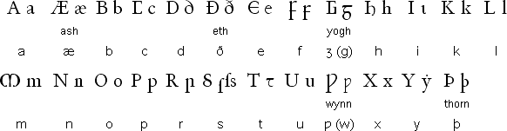

Old English pronunciation
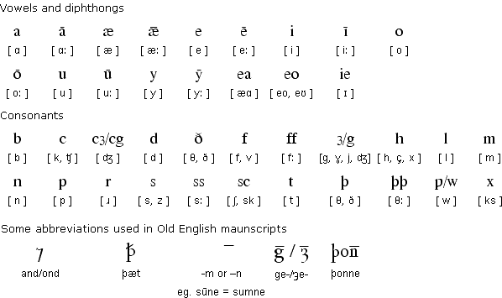

Notes
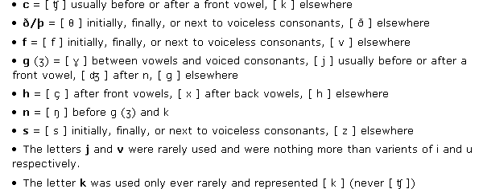

Sample text in Old English (Prologue from Beowulf)

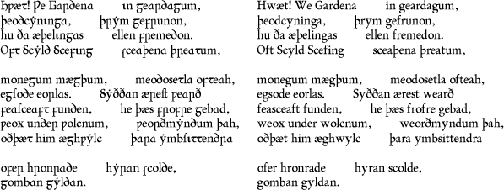

Modern English version
LO, praise of the prowess of people-kings
of spear-armed Danes, in days long sped,
we have heard, and what honor the athelings won!
Oft Scyld the Scefing from squadroned foes,
from many a tribe, the mead-bench tore,
awing the earls. Since erst he lay
friendless, a foundling, fate repaid him:
for he waxed under welkin, in wealth he throve,
till before him the folk, both far and near,
who house by the whale-path, heard his mandate,
gave him gifts:
Most of the information on this page was provided by Niall Killoran
Copyright 1998-Simon Ager

